INTE130 – Object-Oriented Programming

Name: Braah Ali AL_Duwaiki
ID:2421261
Mr: Akbar Khanan

One-Person Company Systems -PartA
e-Person Company Concept
A one-person company is a company owned and operated by only one person. The Founder is responsible for making all the decisions and running the company.Nowadays, technology is of great help in managing a business by one person. Technology can perform many tasks automatically
For instance:
Some systems can respond to customers automatically
Tools can help track money and expenses
Tools can help publish advertisements
Therefore, the Founder can save time and concentrate on key decisions rather than performing all the tasks manually
. Architecture of a One-Person Company
The system is divided into small parts to make the work easy
Main parts
Founder
The main person who takes all the decisions
Digital Agents:
Programs used to assist in performing certain tasks
Tasks:
These are the tasks to be performed, such as responding to customers or analyzing data
System Components:
Database
User interface
Processing system
Role of Multi-Agent Systems
A multi-agent system means having more than one agent working together
Each agent has a specific role to play. For example:
Finance agent → handles money
Marketing agent → handles promotions
Support agent → answers customers
These agents provide suggestions. The Founder makes the final decision
The system becomes more organized and easier to manage
Programming Perspective (OOP)
We can design this system using Object-Oriented Programming (OOP)
We use classes like:
Founder
Agent
Task
Each class has its own data and functions
We also use:
Inheritance → agents have common features
Encapsulation → each agent manages its data
Polymorphism → each agent works differently
The system becomes simpler and more organized.

Business Idea and Project Proposal-Part B
EduTaskMate Name:
The business is an online system for helping students to improve their study and organize their tasks
The system is designed to:
Improve the way students study
Manage tasks
Provide simple academic assistance
The idea is to make the students’ work easier by using technology and smart agents
Target Customers
The target customers of the business include:
Students in school
Students in the university
Any person who needs assistance in organizing their work
Why This Business Can Be Managed by One Person
The reason why the business can be managed by one person is that most of the tasks in the business are carried out by digital agents
For example:
The agents handle customer replies
The agents handle the marketing
The agents handle money tracking through the finance agent
The Founder of the business only needs to monitor and make decisions
Proposed Agents
The proposed agents in the business include:
Finance Agent
Tracks income and expenses
Checks the profit
Marketing Agent
Suggests promotions
Helps increase users
Customer Support Agent
Answers customer questions
Helps the customer
Operations Agent
Organizes tasks
Manages the work
Example Interaction
The way the agents interact with the Founder is as follows:
The Founder asks:
How can I increase users?
The marketing agent replies:
'Offer a discount'
The finance agent replies:
'Budget is okay'
The Founder then decides to accept the idea.

System Planning & Design-Part C
System Architecture:
It is designed in such a way that one individual alone could manage the entire process with the minor assistance of digital agents
Firstly, the Founder comes up with a job that needs to be done based on the requirements of the business, such as expanding user-base or improving customer support services
Then this job is handed over to all the digital agents and each one approaches the job from their perspective; thus, the marketing agent suggests promotions and the finance agent validates them
Finally, all the agents come up with the suggestions that are presented to the Founder for consideration.
Multi-Agent Structure:
The system is made up of many agents with different responsibilities.
Finance Agent
It deals with all matters concerning money by monitoring income and expenditures to see if the business can make certain decisions.
Marketing Agent
It is concerned with the growth of the business and bringing in new customers. It suggests things such as discounts and marketing campaigns.
Customer Service Agent
It makes the job of solving customer complaints easier and answering their questions simpler.
Operations Agent
It is concerned with day-to-day activities and improving the workflow
It is important to note that all agents work individually but help the Founder make good decisions.
System classes:
Company, Founder, Agent, Task, and Recommendation are the major classes in the system.
The Company controls the entire system. The Founder generates tasks and makes decisions.
Agent is the abstract class from which all agents inherit.
Task contains the tasks assigned to agents.
Recommendation holds the outputs of agents.

UML Diagram:
Founder
Name
createTask()
Company

Task
taskname

taskName
taskName

Agent
processTask()
8
SupportAgent
FinanceAgent
MarketingAgent

OperationsAgent
Recommendation
message

UML Diagram Description:
U UML diagram represents the process flow of the system.
The founder generates task requests and forwards them to the agents.
The agents process the tasks and give feedback.
All the agents extend the main agent class.
The company unites all the parts.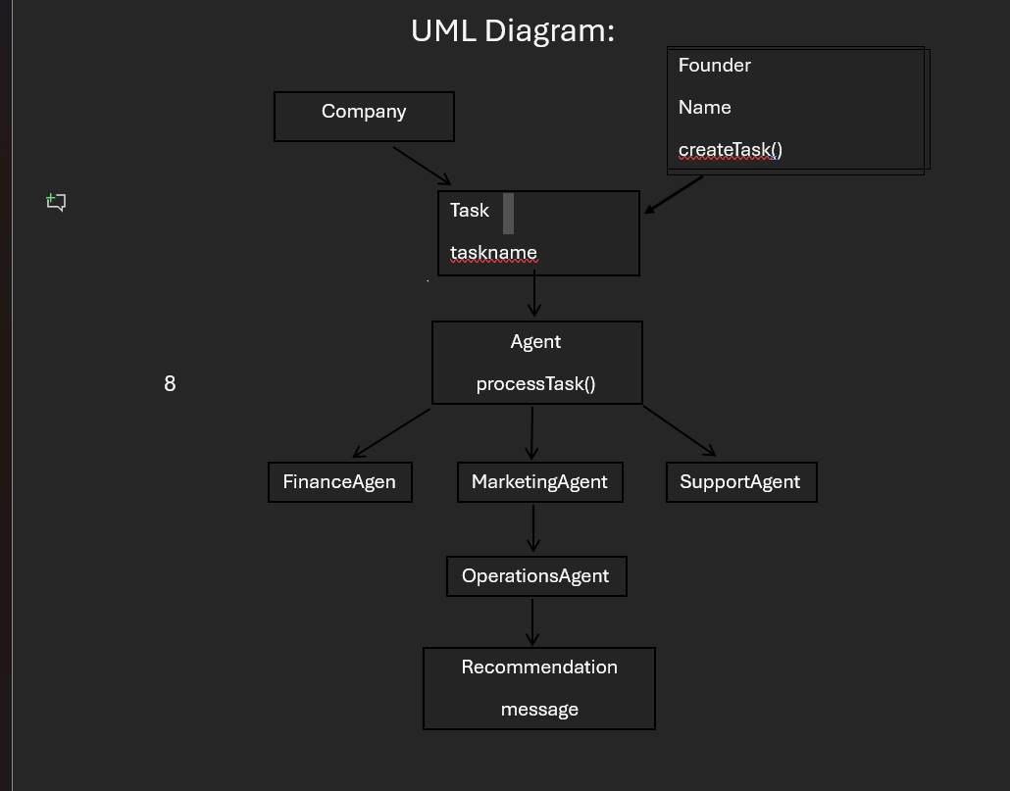

System Implementation -Part D
https://colab.research.google.com/drive/1Cm_yU2QI6wlIoDC-YWIw5iH0T6up2kE1?usp=sharing
class Recommendation:
def __init__(self, message):
self.message = message

class Task:
def __init__(self, taskName):
self.taskName = taskName

class Agent:
def __init__(self, name):
self.name = name

def processTask(self, task):
pass

class FinanceAgent(Agent):
def processTask(self, task):
return Recommendation(f"Finance Agent {self.name}: Budget for '{task.taskName}' is okay.")

class MarketingAgent(Agent):
def processTask(self, task):
return Recommendation(f"Marketing Agent {self.name}: Suggesting a discount for '{task.taskName}'.")

class SupportAgent(Agent):
def processTask(self, task):
return Recommendation(f"Support Agent {self.name}: Ready to help with '{task.taskName}'.")

class OperationsAgent(Agent):
def processTask(self, task):
return Recommendation(f"Operations Agent {self.name}: Daily work for '{task.taskName}' is ready.")

class Founder:
def __init__(self, name):
self.name = name

def createTask(self, name):
print(f"Founder {self.name} is making a new task: {name}")
return Task(name)

def makeDecision(self, recommendations):
print("\n--- Founder Reviewing Advice ---")
for rec in recommendations:
print("Agent Says:", rec.message)
print("\nFinal Decision: The Founder approves the project! ✅")

founder = Founder("Braah")
my_task = founder.createTask("Increase Users")
all_agents = [FinanceAgent("FinBot"), MarketingAgent("MarkBot"), SupportAgent("HelpBot"), OperationsAgent("WorkBot")]

all_advice = []
for a in all_agents:
all_advice.append(a.processTask(my_task))

founder.makeDecision(all_advice)

GitHub Repository Link:
https://github.com/braah-netizen/my-INTE130-PROJECT/tree/main

Academy Certificate-Part E and References.
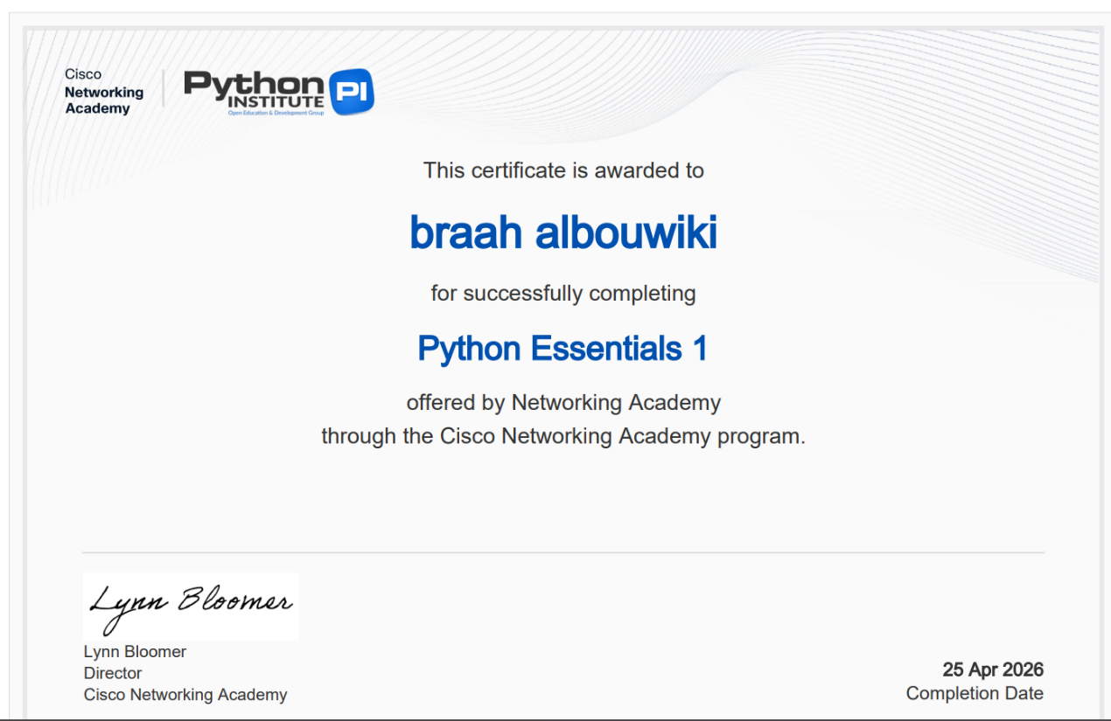

Python Software Foundation. (2026). Python Language Documentation. Available at: https://www.python.org/doc/
Google Colab. (2026). Google Research: Interactive Development Environment. Available at: https://colab.research.google.com/
GitHub, Inc. (2026). GitHub Repository Hosting Service. Available at: https://github.com/
Oracle Corporation. (2026). Object-Oriented Programming Concepts: Inheritance and Polymorphism. Available at: https://docs.oracle.com/
Investopedia. (2024). Solopreneur: Definition and Business Model. Available at: https://www.investopedia.com/
Cisco Networking Academy. (2026). Python Essentials 1: Course Completion and Certification. Available at: https://www.netacad.com/
IBM SkillsBuild. (2026). Professional Development in Software Engineering. Available at: https://skillsbuild.org/
Russell, S., & Norvig, P. (2021). Artificial Intelligence: A Modern Approach (4th ed.). Pearson Education.

